**LAB SET 8**

Write an animated program to construct a car like structure on a track and perform

the following in a menu:

1. Start the car.
2. Change the direction of moving car from left to right and vice versa.
3. Increase and decrease the speed.
4. Stop the car.
5. A sub menu to change color of the car body.

//Program

//Akarsh Singh

#include <stdio.h>

#include <stdlib.h>

#include <GL/glut.h>

#include<math.h>

//declare matrix of colors

float colors[4][3]={{1.0,0.0,0.0},{0.0,1.0,0.0},{0.0,0.0,1.0},{1.0,1.0,0.0}};

int body_color=0; //index to set body color

double s=0.0; // speed variable

double tr=0.0; // rotation with an arbitrary axis (tr,tr,tr);

void car()

{

//car wheels

glPushMatrix();

glTranslatef(-0.9,-0.02,-0.2);// move the torus to left

glutSolidTorus(0.01,0.03,25,25);// render a torus at the center

glPopMatrix();

glPushMatrix();

glTranslatef(-0.6,-0.02,-0.2);

glutSolidTorus(0.01,0.03,25,25);

glPopMatrix();

//car body

glColor3fv(colors[body_color]);

glPushMatrix();

glTranslatef(-0.75,0.1,-0.3);

glScalef(2.5,2.0,1.0);

glutSolidCube(0.1);

glPopMatrix();

glColor3f(0.5,0.5,0.5);

glPushMatrix();

//front mirror

glTranslatef(-0.6,0.1,-0.4);

glScalef(0.5,2.0,1.0);

glutSolidCube(0.1);

glPopMatrix();

//back mirror

glPushMatrix();

glTranslatef(-0.9,0.1,-0.4);

glScalef(0.5,2.0,1.0);

glutSolidCube(0.1);

glPopMatrix();//dicky

glColor3fv(colors[body_color]);

glPushMatrix();

glTranslatef(-0.95,0.1,-0.4);

glScalef(1.2,2.0,1.0);

glutSolidCube(0.1);

glPopMatrix();

//banet

glPushMatrix();

glTranslatef(-0.55,0.1,-0.4);

glScalef(1.2,2.0,1.0);

glutSolidCube(0.1);

glPopMatrix();

}

void display()

{

glClear(GL_COLOR_BUFFER_BIT|GL_DEPTH_BUFFER_BIT);

glColor3f(0.4,0.4,0.4);

glPushMatrix();

glRotated(20,tr,tr,tr);

car();

glPopMatrix();

//Road

glColor3f(0.0,0.0,0.0);

glPushMatrix();

glTranslated(-1.0,0.0,0.2);

glScalef(4.5,1.2,0.0);

glutSolidCube(1.0);

glPopMatrix();

glutSwapBuffers();

glFlush();

}

void init()

{

glClearColor(1.0,1.0,1.0,0.0);

}

void reshape(int w,int h)

{

glViewport(0,0,w,h);

glMatrixMode(GL_PROJECTION);

glLoadIdentity();

if(w<=h)

glOrtho(-30.0,30.0,-30.0*(GLfloat)w/h,30.0*(GLfloat)w/h,-10.0,10.0);

else

glOrtho(-30.0*(GLfloat)h/w,30.0*(GLfloat)h/w,-30.0,30.0,-10.0,10.0);

glMatrixMode(GL_MODELVIEW);

glLoadIdentity();

}

void idle()

{

s=0.001;

glTranslated(s,0.0,0.0);

glutPostRedisplay();

}

void mainmenu(int id)

{

switch(id)

{

case 1: //Start car

glutIdleFunc(idle);

break;

case 2: //Stop Car

glutIdleFunc(NULL);

break;

case 3: //Turn left

tr+=0.01;

break;

case 4: //Turn Right;

tr-=0.01;

break;

case 5: //Increase Speed

if(s==1.01)

break;

s+=0.001;

break;

case 6: //Decrease Speed

if(s==0.0)

break;

s-=0.0001;

}

glutPostRedisplay();

}

void colormenu(int id)

{

body_color =id;

}

int main(int argc,char **argv)

{

int id;

glutInit(&argc,argv);

glutInitDisplayMode(GLUT_RGB|GLUT_DOUBLE|GLUT_DEPTH);

glutInitWindowSize(600,400);

glutCreateWindow("CAR APPLICATION");

glutDisplayFunc(display);

init();

glEnable(GL_DEPTH_TEST);

id=glutCreateMenu(colormenu);

glutAddMenuEntry("RED",0);

glutAddMenuEntry("GREEN",1);

glutAddMenuEntry("BLUE",2);

glutAddMenuEntry("YELLOW",3);

glutCreateMenu(mainmenu);

glutAddMenuEntry("Start Car",1);

glutAddMenuEntry("Stop Car",2);

glutAddMenuEntry("Turn Left",3);

glutAddMenuEntry("Turn Right",4);

glutAddMenuEntry("Speed Up",5);

glutAddMenuEntry("Speed Down",6);

glutAddSubMenu("COLORS",id);

glutAddMenuEntry("Quit",7);

glutAttachMenu(GLUT_RIGHT_BUTTON);

glutMainLoop();

return 0;

}

**OUTPUT**

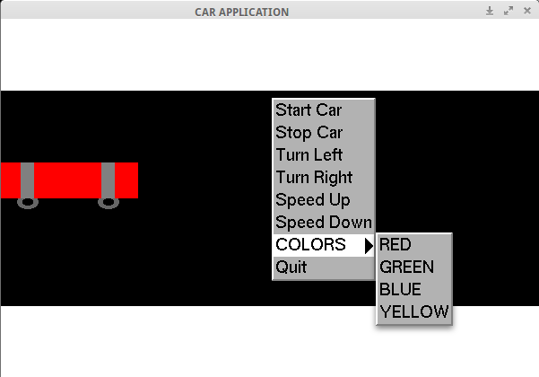

**SCREENSHOT 1**

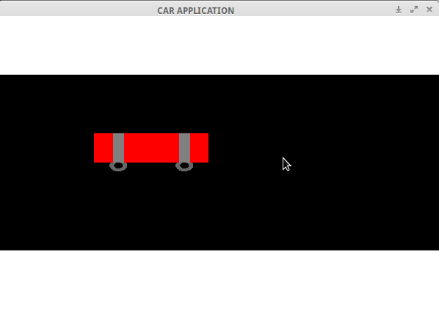

**SCREENSHOT 2: Start Car**

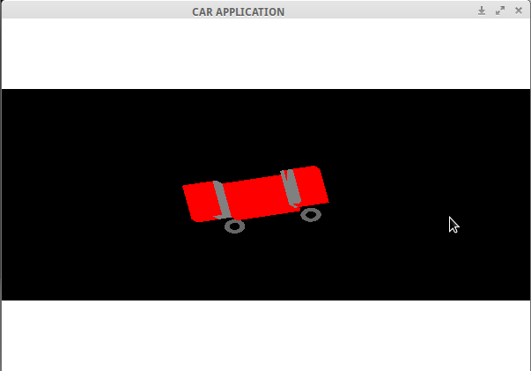

**SCREENSHOT 3: Turn Left**

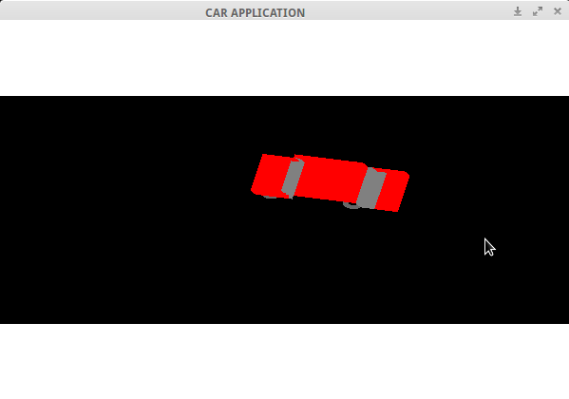

**SCREENSHOT 4: Turn Right**